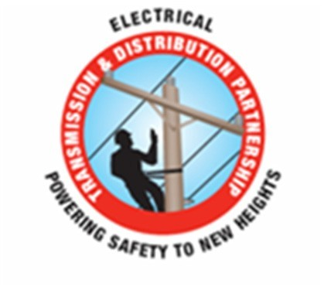Electrical Transmission

& Distribution

Partnership

Continuing Education

Training

‐Isolate & Insulate

Facilitator
Guide

‐2nd Quarter 2020

This page intentionally left blank

2
Introduction

The Insulate & Isolate Refresher course is a facilitator led process. The facilitator may choose to augment the material with videos, handouts or other media to enhance the learning experience. The facilitator may want to incorporate visual aids such as rubber gloves, sleeves, line hose etc. to enhance the presentation.

Using this material combined with practical experience, good presentation skills, and knowledge of adult learning techniques, the facilitator has a greater opportunity to deliver the information effectively.

Microsoft® PowerPoint® combined with good instructional skills and instructor/student dialogue help with information retention and understanding. PowerPoint® presents the information to the attendee and the facilitator summarizes the content of the slides. It is critical to engage and involve the attendee in the process. Ask open-ended questions that will elicit conversation and discussion but be cautious to maintain control of the discussion.

Conversation and scenarios are good but can cause the discussion to run long. If it seems like the group is losing focus during the course, the facilitator can direct the group back on track by using comments like “This is a great discussion, but let’s get back to the subject at hand”.

Another tool is the “Parking Lot” which is simply a newsprint chart or dry erase board or note pad where the facilitator records unanswered questions during the meeting and that may require more research. It is vital to capture any ongoing discussions or questions on the “Parking Lot” and follow up when the information is known.

This refresher is to be delivered in the second quarter of 2020. Delivery time is approximately 1 to 1.5 hours in one setting or divided-up into three, twenty to thirty-minute settings. It is critical that the facilitator makes him or herself familiar with the material prior to delivery.

At the end of this document is the ET&D Partnership’s Insulate & Isolate Best Practice that the presenter can use in conjunction with the PowerPoint® presentation to augment the materials. In addition, there is an accompanying handout from AB Chance that describes methods to inspect rubber-insulating gloves.

This page intentionally left blank

4
Slide 1-1

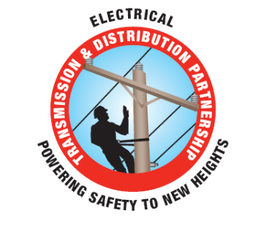

Isolate & Insulate
Continuing Education
2nd Quarter 2020

1-1

Introduce the module. Explain that the intent of this presentation is as a continuing education training topic related to certain aspects from the ET&D 10-Hour OSHA training class, the OSHA Partnership Best Practices, and/or incident trending analysis.

As an organization we are dedicated to safety and the value it has on one’s livelihood of themselves and their families. It is important that “we” plan out and even rehearse (in our head) what our job responsibilities are before we do them to ensure we have thought of all the “what if this happens?” questions and implemented ways to eliminate and/or mitigate the potential for an injury or incident.

In April of 2019 the OSHA Partner Members conducted an injury analysis with the goal of investigating trends to eliminate fatal incidents occurring within the Electrical Transmission and Distribution Industry. Without going into many of the specifics:

They looked at 645 cases, which equated to roughly 92,938,987 man-hours, all within CY2018.
Of these 645 cases it was found strains/sprains, struck-by and cuts/punctures lead the way, but;
There was something else that was staggering. Electrical Contact and Arc Flash injuries were high on the list as well with 35 events. This was an INCREASE from 2017, when 26 of these events occurred.

Arc Flash events increase 70% from 2017 to 2018.
Electrical Contacts increased almost 13% from 2017 to 2018.
Since 2015 the Industry has experienced 142 Electrical Contact and Arc Flash events (71 each).
When looking at the Electrical Contact and Arc Flash data it obviously shows us there is a need to ensure we are practicing good insulate and isolate techniques and always ask yourself: “Am I or someone, or will I or someone, be in the “Line of Fire”?

The material for review will provide you with example techniques, useful information to help you plan elimination and mitigation practices as well as some scenarios to review and discuss.

Slide 1-2

Never Second Guess Electrical
Hazards! If there is any doubt,
STOP!

Consult a Supervisor, Journeyman and/or a Safety Professional

1-2

There is always time to do the job the right way the first time
Slide 1-3

Objectives
Upon completion of this continuing education module you should be able to:
Describe the difference between Isolate and Insulate
Describe how current flow through the body can cause injury
Describe testing requirements for rubber goods and live- line tools
Describe Minimum Approach Distance (MAD)
Describe ways to Isolate and/or Insulate workers from electrical hazards

1-3

Explain that this is the 2nd quarter 2020 topic. Explain the objectives of this course.

Slide 1-4

Key Safety Fundamental

To avoid hazardous differences in electrical potential:

Isolate yourself from the hazard

Insulate yourself from the hazard

1-4

Explain that two methods of electrical protection are “insulate” and “isolate” with the third method of protection being equal potential grounding and bonding. This topic references the ET&D Insulate & Isolate Best Practice. Explain the intent is to provide information and aid workers, which may be exposed to hazardous differences in electrical potential in selecting protective measures.
Slide 1-5

Facts

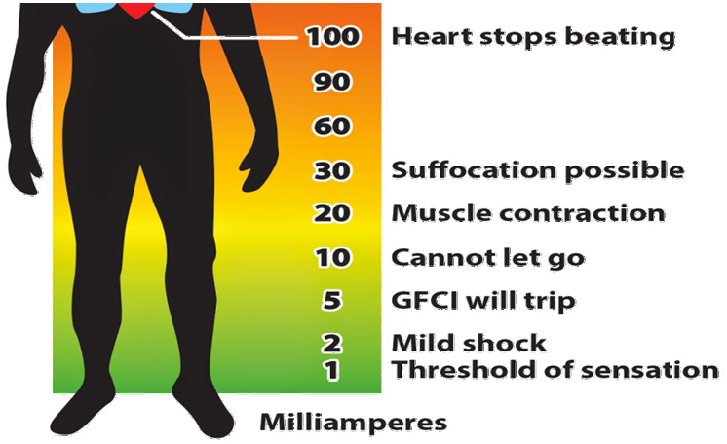Each year workers are killed or seriously injured due to current flow through their body

1-5

Explain how increasing levels of current flow through the human body can have devastating results. As little as 100 milliamps (1/10 of an amp) can cause the heart to stop or go out of its normal rhythm.

Slide 1-6

Insulated Defined

The IEEE defines
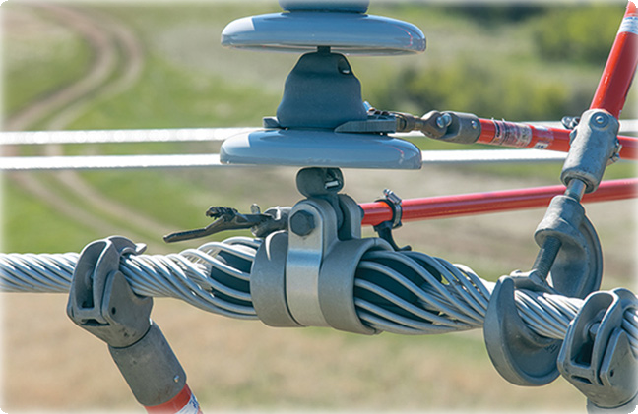Insulated as:

• Separated from other conducting surfaces by a dielectric substance or air space permanently offering a high resistance to the passage of current

Live-line tools “insulate” the worker from the energized part
Note: The Institute of Electrical and Electronics Engineers (IEEE, pronounced I triple E) is a professional association formed in
1963 from the amalgamation of the American Institute of Electrical Engineers and the Institute of Radio Engineers. Today, it is the world’s largest association of technical professionals with more than
400,000 members in chapters around the world.

1-6

Explain that insulated (from the IEEE dictionary) means: Separated from other conducting surfaces by a dielectric substance or air space permanently offering a high resistance to the passage of current and to disruptive discharge through the substance or space.
Slide 1-7

Insulated Defined

OSHA defines
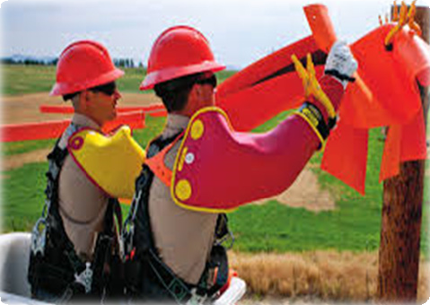Insulated as:

• Material relied upon to insulate the conductor from other conductors or conducting parts or from ground

Rubber goods “insulate” the worker from the energized part

1-7

Explain that insulated (from 29 CFR Subpart V, §1926.968) means: Insulation (cable). Material relied upon to insulate the conductor from other conductors or conducting parts or from ground. Explain that rubber goods insulate the worker from the energized part.

Slide 1-8

ET&D Best Practice

When working on primary conductors utilizing the Gloving Method:

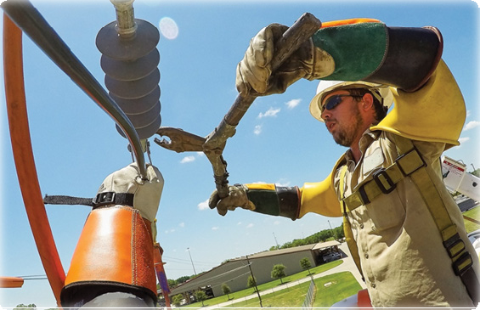• The worker wears insulated rubber gloves and sleeves

1-8

Explain that when working on primary conductors utilizing the “Rubber Gloving Method”, the line worker has a system of insulation built into the work practice.
Slide 1-9

Insulate Defined

The “back-up” systems to a lineman’s insulated rubber gloves are:
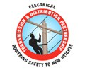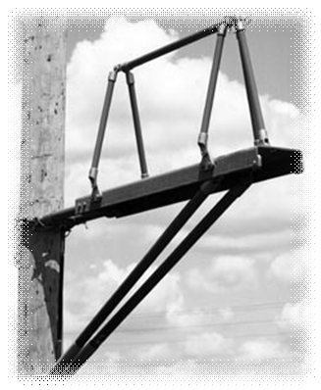• An insulated platform
• An insulated boom
• Insulated covering material

1-9

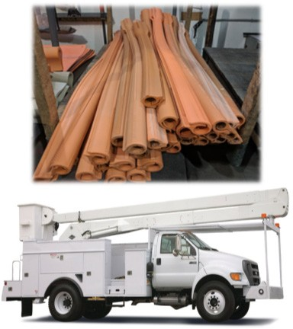Explain that the ET&D “Insulate & Isolate” Best Practice States the following:

1. Insulated: (1) The use of Insulated Protective Equipment (IPE) to protect the line worker while gloving energized lines/equipment.

2. Insulating Personal Protective Equipment (IPPE): Rubber Gloves and Sleeves.

3. Insulating Protective Equipment (IPE): rubber blankets, rubber line hose, rubber hoods, plastic covers, etc.
Slide 1-10

Benefit

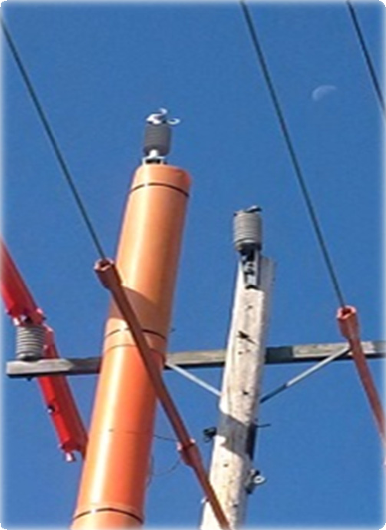Insulating tools, equipment, and safe work practices allow a worker to safely work on, and around energized equipment and conductors

1-10

Explain that Insulating tools, equipment, and work methods allow a worker to work safely on, and around energized equipment and conductors

End of session one
Session one key points review

Key Points-Session one

1. Define Insulate.
a. To cover with a material relied upon to insulate the conductor from other conductors or conducting parts or from ground.
b. To remove the system from normal potentials.
c. To remove the person from the exposure.

2. As little as normal rhythm.
a. 10
b. 100
c. 1,000
milliamps can cause the heart to stop or go out of its

3. Never Second Guess Electrical Hazards.
a. True
b. False

1-11

The presenter should have touched on the following items when Explaining session one:

1. Define Insulate.

a. To cover with a material relied upon to insulate the conductor from other conductors or conducting parts or from ground.
b. To remove the system from normal potentials.
c. To remove the person from the exposure.

2. As little as milliamps can cause the heart to stop or go out of its normal rhythm.

a. | 10
b. | 100
c. | 1,000

3. Never Second Guess Electrical Hazards.

a. True
b. False
Begin session two

Slide 2-1

Rubber Gloves

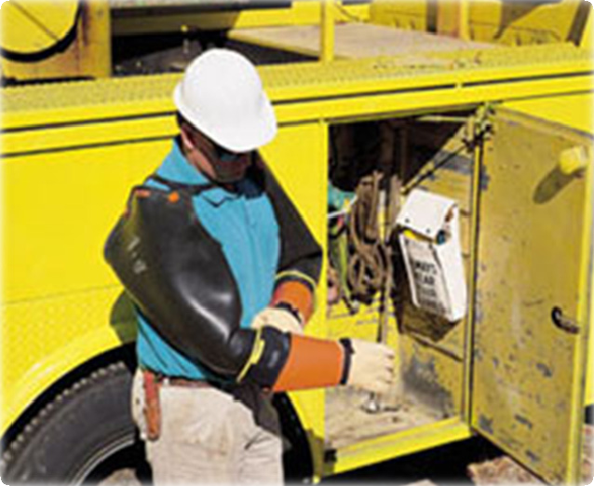Rubber gloves and sleeves must be physically and visibly inspected before each use!

2-1

Explain that when inspecting rubber gloves and sleeves one must look for any/all the following possible issues:

Holes

Tears

Cuts

Punctures

Crazing

Ozone damage

Cracking

Deformation

Petroleum damage

Current inspection date

Any condition that may cause the user to be suspect of the insulating value of the gloves or sleeves. Explain that inspecting the leather protectors is equally as important as inspecting the rubber gloves. Protectors that may contain embedded splinters or metal slivers can damage the rubber glove. In addition, protectors that are soaked or impregnated with a petroleum product can cause damage as well.

This is a good time to review the attached glove inspection document from AB Chance.
Slide 2-2

Insulating Equipment

Secure the work area

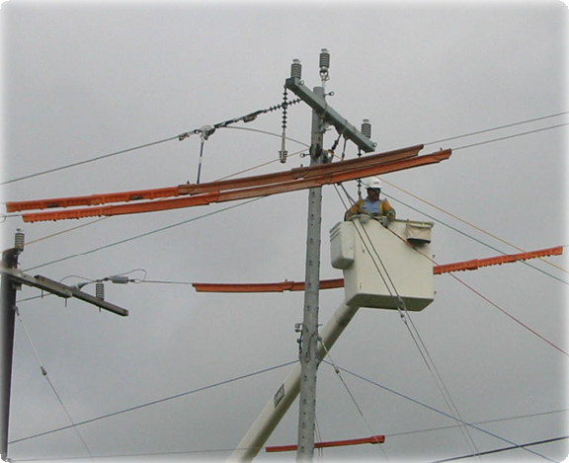Remove all hazards

Protect workers from those hazards that cannot be eliminated

2-2

Explain that we install protective cover to provide protection from accidental contact. All the areas that the conductor tails could contact are protected by line cover material.

Slide 2-3

Dielectric Test

Equipment Type | Inspection Schedule
Rubber Glove | Before first issue then Semi Annually
Rubber Sleeve | Before first issue then Annually
Rubber Blanket | Before first issue then Annually
Rubber Hose, Hoods etc. | Suspect insulating value

These are the minimum requirements required by OSHA. Company policy, client and/or contract requirements may mandate shorter inspection cycles

2-3

Explain that these are the minimum requirements required by OSHA. Company policy, client, and/or contract requirements may exceed these inspection cycles. Explain that if there is any reason to be suspect that the insulating ability of any rubber protective equipment is suspect, remove the equipment from service, and have it dielectrically tested.
Slide 2-4

Live-Line Tools

Minimum approach distance must be maintained
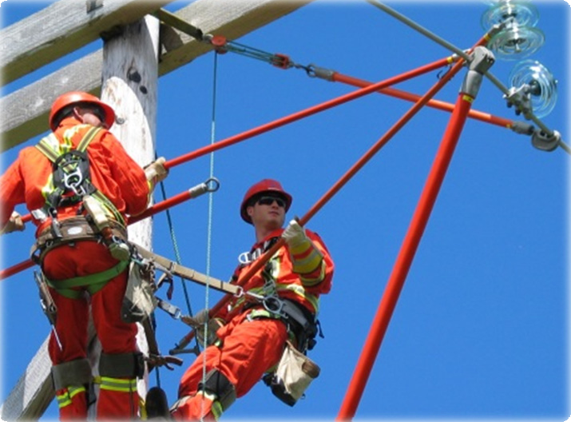• The worker’s hand
• The hot end of the stick

2-4

Explain that the key to live line tools is the minimum approach distance, cleanliness and tested tools. The minimum approach distance shall always be observed. Live line tools are built to a standard of 100,000 volts per foot of fiberglass stick. The OSHA standards require that all sticks pass a wet test.

Slide 2-6

Live-Line Tools

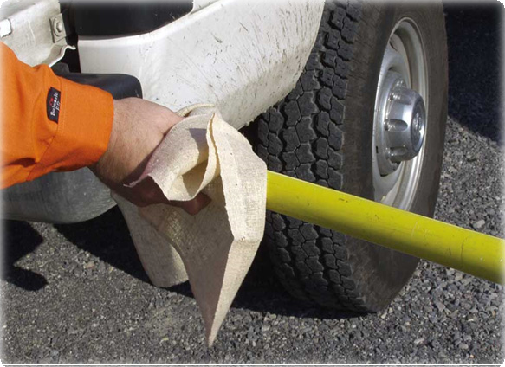Live-line tools shall be removed from service every 2 years for examination, cleaning, repair, and testing as needed

2-5

Explain that all live line tools must be checked for proper test date, physical wear, and be wiped down prior to use.
Slide 2-7

Live Line Tools

Each live-line tool shall be wiped clean and visually inspected for defects before use each day

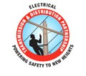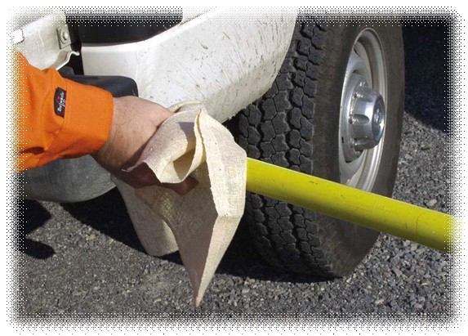Would you do hot work with dirty sticks?

Is an insulated boom any different?

Trigger the animation and this picture will appear.

2-6

Explain that the boom of an insulated aerial lift should be wiped down and clean. This helps insure the insulating value of the boom.

Slide 2-8

Live-Line Tools

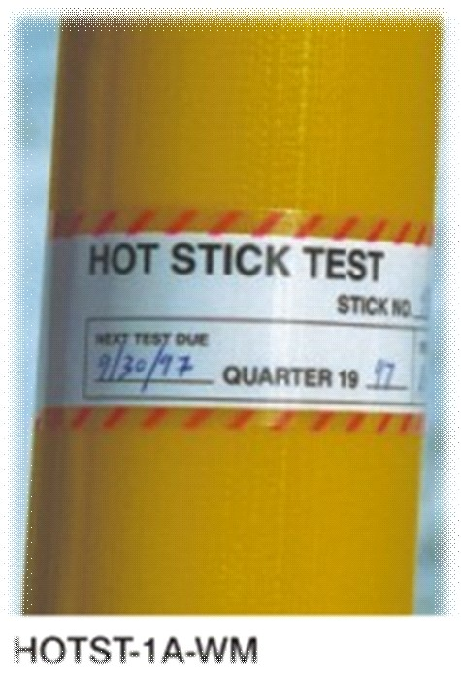Test the tool's integrity along its entire working length

If the tool is made of fiberglass-reinforced plastic, test its integrity under wet conditions

2-7

Explain that the OSHA standards require that at minimum live-line tools used for primary employee protection shall be removed from service every 2 years, for examination, cleaning, repair, and testing as follows: Each tool shall be thoroughly examined for defects. If a defect or contamination that could adversely affect the insulating qualities or mechanical integrity of the live- line tool is found, the tool shall be repaired and refinished or shall be permanently removed from service.
Slide 2-9

Second Point of Contact

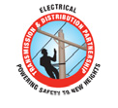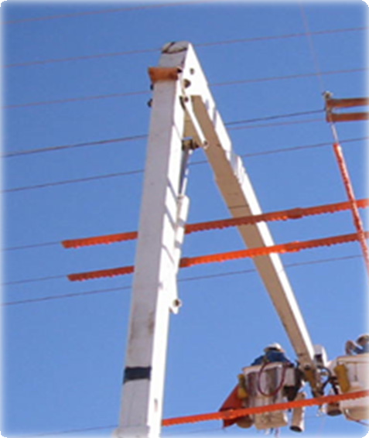If any part of a boom can contact an energized phase, cover the phase

2-8

Explain that this is a good example of covering the area below the bucket. Booms should not contact energized parts.

Slide 2-10

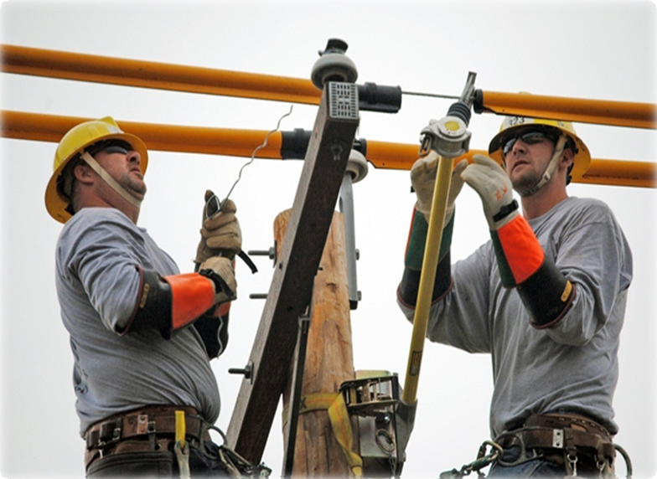

Second Point of Contact

Eliminate second point of contact hazards
Cross arm not covered
Workers not wearing sleeves
Minimum approach distance violation on tie-wire

Trigger the animation and the circles appear indicating the minimum approach distance issue between the tie wire and the worker’s body.

2-9

Explain that in this picture there are numerous concerns. The cross arm is not covered. The arm represents a second point of contact. Neither line worker is wearing rubber-insulating sleeves.
Slide 2-10

Second Point of Contact

Second points of contact include:
• Pole
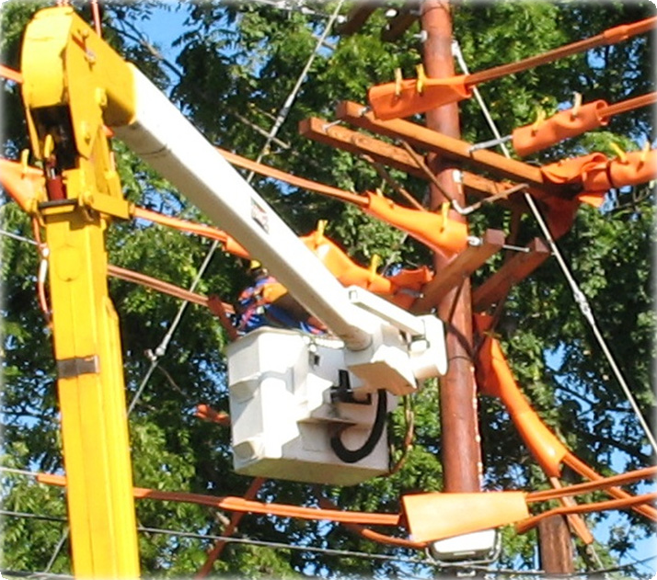• Cross arm
• Open spot in cover
• Guy wires
• Other phases/Neutral

2-10

Explain that this is an excellent example of using line cover material to secure the work area. Point out that the blankets are wrapped around the energized parts to eliminate any second points of contact.

End session two
Session two key points review

Slide 2-11

Key Points-Session two

1. List some items to look for when inspecting rubber gloves and sleeves.
a. Holes, Tears, Cuts, Punctures
b. Crazing, Ozone damage, Cracking
c. Deformation, Petroleum damage, Current inspection date
d. All the above

2. According to OSHA, rubber-insulating gloves are required to be electrically tested at
least every
a. 2 b. 4 c. 6
months.
3. Live-line tools are required to be removed from service and inspected every
_ years.
a. 2 b. 4 c. 6

2-11

The presenter should have touched on the following items when Explaining session one:
1. List some items to look for when inspecting rubber gloves and sleeves. a. Holes, Tears, Cuts, Punctures
b. Crazing, Ozone damage, Cracking
c. Deformation, Petroleum damage, Current inspection date
d. All the above

2. According to OSHA, rubber-insulating gloves are required to be electrically tested at least every months.

a. 2 b. 4 c. 6

3. Live-line tools are required to be removed from service and inspected every
years.

a. 2 b. 4 c. 6
Begin session three

Slide 3-1

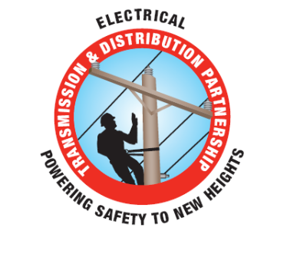Isolate

3-1

Explain that the following section will explain, “Isolate”

Slide 3-2

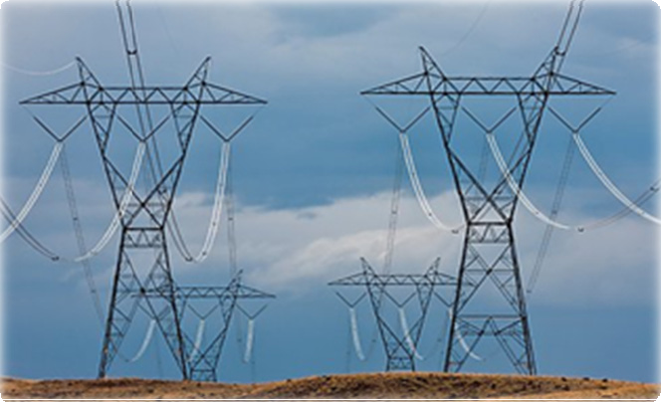

Generally Speaking

You may consider a system, circuit, and/or apparatus isolated when it is removed from normal sources of potential

• The key word here is Normal
source

• Induction is an Abnormal
source

Induction

Trigger animation and the arrow will appear indicating that there may be induced voltage present from an adjacent circuit.

3-2

Explain that even though switches may be opened, jumpers may be lifted, and breakers may be open, none of these will prevent induced voltages from parallel or adjacent energized lines, equipment failure, and/or a lightning strike.
Slide 3-3

Isolate Defined

Physically separated, electrically and mechanically from all
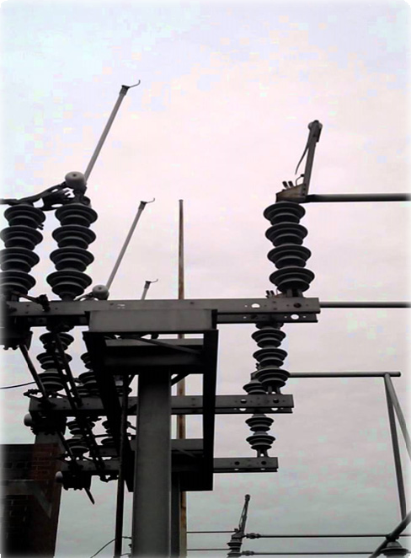sources of electrical energy
Such separation may not eliminate the effects of electrical induction!

3-3

Explain that according to the IEEE isolated means: (A) physically separated, electrically and mechanically, from all sources of electrical energy. Such separation may not eliminate the effects of electrical induction.

Slide 3-4

Isolate Defined

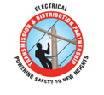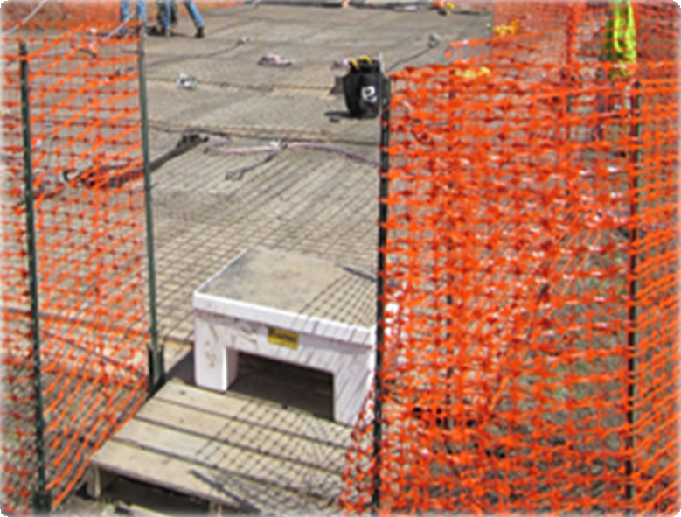Not readily accessible to persons unless special means for access are used

3-4

Explain that according to the IEEE another aspect of “isolated” means: “Not readily accessible to persons unless special means for access are used”. In this picture, the two fences (inner and outer) are used to isolate employees on the outside of the fence from contacting people or equipment on the inside of the fence. The dedicated access/egress path shown in the picture is designed to limit the entry/exit points.
Slide 3-5

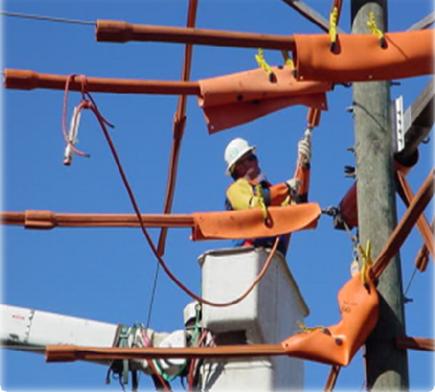

Line Cover

or second points of contact within M.A.D.
Properly rated Insulated
Protective Equipment (IPE) shall be installed in the order of ‘nearest first’ and removed in the reverse
order
The line worker shall NEVER turn their back on exposed energized conductors

3-5

Explain that properly rated Insulated Protective Equipment (IPE) shall be installed in the order of
‘nearest first’ and removed in the reverse order.

a. Energized or de-energized part(s) may have to be temporarily covered in order to install
IPE on all parts necessary to insulate/isolate the part that is to be worked on.

b. The part to be worked shall only be uncovered after all IPE has been installed in the work zone that will allow no contact with conductors or equipment at a different potential.

c. IPE shall be installed/removed in such a manner so that the worker is not exposed to contact from energized conductors or second points of contact.

d. The line worker shall NEVER turn their back on exposed energized conductors or second points of contact within M.A.D.
Slide 3-6

Determine Minimum Approach

The employer must determine minimum approach distance

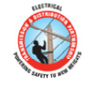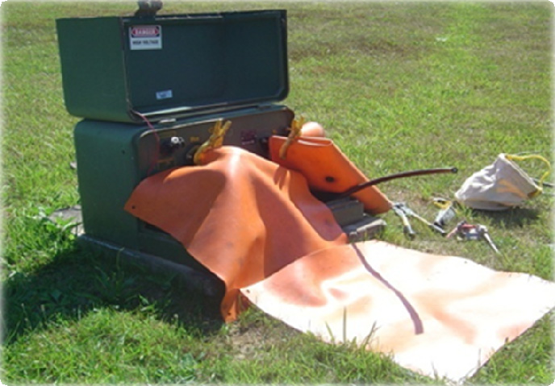• Engineering analysis

• Customer requirement

• OSHA tables

3-6

Explain that OSHA mandates that workers must maintain certain minimum approach distances from energized parts.

Slide 3-7

Minimum Approach Distance

Another point to Explain is the

Line workers must maintain the minimum approach distance from exposed energized parts

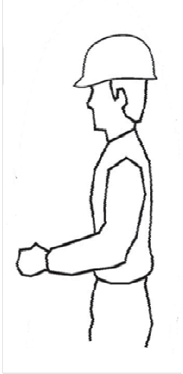E Energized Part

MAD
requirement that the employer ensures that workers do not work in a position that if the worker were to slip and/or fall they could contact an energized part.

Ergonomic
Component

3-7

Explain that OSHA requires that the employer shall ensure that no employee approaches or takes any conductive object closer to exposed energized parts than the employer's established minimum approach distance, unless:

a. The employee is insulated from the energized part

b. The energized part is insulated from the employee and from any other conductive object at a different potential, or

c. The employee is insulated from any other exposed conductive object in accordance with the requirements for live-line bare-hand work.

Slide 3-8

Ergonomic Component

Employees should be able to perform all of the following actions without straying into the minimum approach distance:

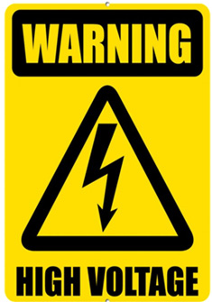• Adjust his or her hardhat

• Maneuver a tool onto an energized part with a reasonable amount of overreaching or under reaching

• Reach for and handle tools, material, and equipment passed to him or her

• Adjust tools, and replace components on them, when necessary during the work procedure
In other words, the “Ergonomic Component” of MAD refers to the necessary movements a worker would make to perform a job task

Trigger the animation and this shape appears explaining the Ergonomic Component of MAD.

3-8

Explain that the ergonomic component of the minimum approach distance accounts for errors in maintaining the minimum approach distance (which might occur, for example, if an employee misjudges the length of a conductive object he or she is holding), and for errors in judging the minimum approach distance. The ergonomic component also accounts for inadvertent movements by the employee, such as slipping. In contrast, the working position selected to maintain the minimum approach distance must account for all of an employee's reasonably likely movements and still permit the employee to adhere to the applicable minimum approach distance. Reasonably likely movements include an employee's adjustments to tools, equipment, and working positions and all movements needed to perform the work.

Explain that OSHA requires that the employer shall ensure that no employee approaches or takes any conductive object closer to exposed energized parts than the employer's established minimum approach distance, unless:

a. The employee is insulated from the energized part

b. The energized part is insulated from the employee and from any other conductive object at a different potential, or

c. The employee is insulated from any other exposed conductive object in accordance with the requirements for live-line bare-hand work
Slide 3-9

Conductive Objects

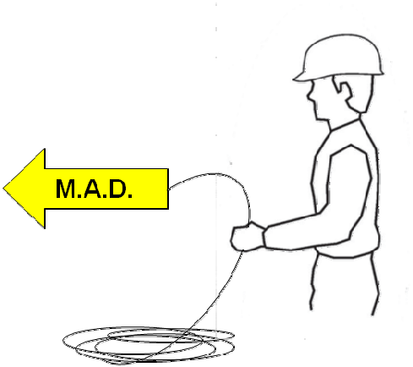Minimum Approach Distance starts at the end of a conductive object held in the hand

3-9

Explain that line cover must be installed in such a manner that all exposed energized parts are covered so that conductive objects held by the line worker cannot contact the energized part.

Another way to Explain Minimum Approach Distance is to change slightly the meaning of MAD. One can say that MAD stands for Minimum Air Distance, or the minimum amount of air that needs to be between a conductive object like a worker and an energized part.

Slide 3-10

Wrap-up
Isolate workers from hazardous potentials or Isolate hazardous potentials from the worker by:
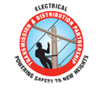• Removing the energized part from normal sources of potential via Open Switches, Remove Jumpers, Open Breakers, Maintain Minimum Approach Distance, Limited Access (i.e. Barricades)

To protect workers from hazardous differences in electrical potential a worker can Insulate from the hazard by using:
• Cover up, Insulating Gloves & Sleeves, Live Line Tools, Insulated Booms

3-10

Review

End session three
Session three key points review

Key Points-Session three

1. Define Isolate.
a. Physically separated mechanically, and electrically from all sources of electrical energy.
b. Grounded and de-energized. c. Covered with line hose.
2. To what does the “Ergonomic Component” of minimum approach distance (MAD) refer?
a. A comfortable working position.
b. Necessary movements required to perform a job task. c. To use vibration resistant tools.

3. Employers must ensure that employees do not work in a position that if the worker slipped or fell the worker could contact an energized part.

a. True b. False

3-11

Key points‐Session three

The presenter should have touched on the following items when Explaining session one:

1. Define Isolate.

a. Physically separated, mechanically and electrically from all sources of electrical energy.
b. Grounded and de-energized. c. Covered with line hose.

2. To what does the “ergonomic component” of minimum approach distance (MAD) refer?

a. A comfortable working position.
b. Necessary movements required to perform a job task.
c. To use vibration resistant tools.

3. Employers must ensure that employees do not work in a position that if the worker slipped or fell the worker could contact an energized part.

a. True
b. False

This page intentionally left blank

26

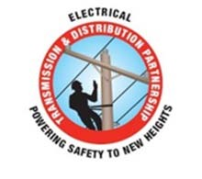

BEST PRACTICE: INSULATE & ISOLATE

SUBJECT: I&I TECHNIQUES FOR THE RUBBER GLOVE METHOD.

PRACTICE STATEMENT: The effective use of Isolate and Insulate equipment and procedures to provide the necessary level of safety when qualified line workers are working on energized lines & equipment.

The employer must ensure that any employee who performs energized line work is qualified (See
29 CFR 1910.269) through training and experience to perform the work assigned.

PRACTICE DESCRIPTION: Properly performed Insulate and Isolate (I&I) techniques used in conjunction with the necessary Insulating Personal Protective Equipment (IPPE) allows a qualified line worker to safely work on and around energized equipment and conductors.

I&I Definitions:
1. Insulated: (1) The use of IPE to protect the line worker while gloving energized lines/equipment.

2. Insulating Personal Protective Equipment (IPPE): Rubber Gloves and Sleeves.

3. Insulating Protective Equipment (IPE): rubber blankets, rubber line hose, rubber hoods, plastic covers, etc.

4. Isolate: (A) Physically separated, electrically and mechanically, from all sources of electrical energy. Such separation may not eliminate the effects of induction. (B) Not readily accessible to persons unless special means for access are used.

5. Minimum Approach Distance (M.A.D.): The distances set forth in 29 CFR 1910.269. This distance is measured from the end of the line workers reach or from the end of any conductive object being handled by the line worker.

6. Second points of contact: Accidental/inadvertent contact made between energized conductors or equipment and pathways to ground, which allows for current to pass through the body. Such contact can be made by the workers body or through a conductive tool/object.

I&I Best Practice: Energized Primary Rubber Gloving Method

1. Only qualified line workers shall be permitted to encroach M.A.D. using this Best Practice.

2. When working from an aerial lift the ‘Cradle to Cradle’ Best Practice shall be observed.

3. Before getting into a position where the qualified line worker can reach into, extend any conductive object into, or extend any other part of the body into the M.A.D., properly rated IPE/IPPE shall be used to insulate/isolate energized conductors and/or other conductive parts at a different potential.

4. For URD equipment the criteria for the ‘Lock to Lock’ Best Practice shall be observed.

5. Properly rated IPE shall be installed in the order of ‘nearest first’ and removed in the reverse order.

a. Energized or de-energized part(s) may have to be temporarily covered in order to install IPE on all parts necessary to insulate/isolate the part that is to be worked on.

b. The part to be worked shall only be uncovered after all IPE has been installed in the work zone that will allow no contact with conductors or equipment at a different potential.

c. IPE shall be installed/removed in such a manner so that the worker is not exposed to contact from energized conductors or second points of contact.

d. The line worker shall NEVER turn their back on exposed energized conductors or second points of contact within M.A.D.

BENEFITS:
Eliminate contact injuries.
Eliminate electric arc flash injuries.
Safely working on energized circuits and maintaining the reliability of the electrical system.

REFERENCES:
NJATC – Effective Cover Up; interactive training.
NECA – Safety Risk Management for the Electrical T&D Line Construction
IBEW – Ten States Safety Manual
OSHA – 1910.269, 1926.950; subpart V
ASTM – F 968-93
ET&D Partnership – Existing Best Practices
WISHA-296-45 – Electrical Workers
IEEE 100 – The Authoritative Dictionary of IEEE Standards Terms (seventh edition)

Questions & Answers

1. What training and skills must a qualified person (qualified line worker) possess?

A: OSHA 29 CFR 1910.269(a)(2)(i) states:

Employees shall be trained in and familiar with the safety-related work practices, safety procedures, and other safety requirements in this section that pertain to their respective job assignments. Employees shall also be trained in and familiar with any other safety practices, including applicable emergency procedures (such as pole top and manhole rescue), that are not specifically addressed by this section but that are related to their work and are necessary for their safety.

OSHA 29 CFR 1910.269(a)(2)(ii) qualified persons shall also be trained and competent in:

The skills and techniques necessary to distinguish exposed live parts from other parts of electric equipment,

The skills and techniques necessary to determine the nominal voltage of exposed live parts,

The minimum approach distances specified in this section corresponding to the voltages to which the qualified employee will be exposed, and

The proper use [and selection] of the special precautionary techniques, personal protective equipment, insulating and shielding materials, and insulated tools for working on or near exposed energized parts of electric equipment.

Note: For the purposes of this section, a person must have this training in order to be considered a qualified person.

2. How much cover is required if you are working on the center phase of a 3 phase circuit on cross arms?

A: If an employee(s) is working on the center phase on all configurations, all conductors, equipment and paths to ground within M.A.D. [including extended reach] effective cover-up (IPE) must be installed for the given voltage being covered.

The term “effective cover-up” is used to describe the installation of phase- to-phase rated insulating protective cover on energized conductors and/or equipment of different potentials when the lineman is within reaching distance or in areas extended by handling conductive objects.
The term “extended reach” is used to describe being within five feet of energized conductors and/or equipment or having a conductive object within five feet of energized conductors and/or equipment.

3. If I’m working on the neutral (or at the neutral position) what IPE is required?

A: If an employee(s) is working on a ground or the neutral, all energized phases within
M.A.D. must be covered with properly rated IPE for the voltage being covered and isulated.

4. What IPPE is required for working on energized ‘secondary voltage’ circuits?

A: If working from an insulated aerial lift workers shall follow the ‘Cradle to Cradle’ Best Practice. If working from a structure, rubber protective insulating sleeves are not required when line workers are working circuits with a potential of 600 volts or less if there is no upper arm exposure and the worker will not encroach the M.A.D.to any primary conductors or equipment.

5. To work on de-energized parts, can a line worker remove their gloves and sleeves after everything is covered properly?

A: No. Unless an equipotential zone (EPZ) has been established, at the work location, for the protection of that worker, gloves & sleeves shall be worn.

6. How much cover is required when working with non-insulated tools?

A: When working with jumpers, tools, chains, conduit or cable slings, or other conductive devices, the employee’s reach is extended the full length of that conductive device. When line workers are handling any such devices (including any tools, material or equipment that the worker may be holding) they shall properly install the properly rated IPE to the extent that all parts within the workers M.A.D. work area - that are at a different electrical potential than the part being worked – are insulated with IPE.

M.A.D. shall not be encroached unless:

1. The employee(s) is insulated or guarded from the energized conductor or equipment by use of properly rated IPE insulated rubber gloves/sleeves rated for the phase voltage involved.
2. The energized conductor or equipment is insulated or guarded by properly rated protective equipment.
3. The employee(s) is isolated, insulated or guarded from any other conductive object(s).

7. How should a line worker be positioned when installing IPE?

A: IPE should be installed from below the conductor(s). Correct positioning of the worker when applying rubber goods is of utmost importance. You cannot work near or adjacent to a conductor that is uncovered if it is within your M.A.D. until it is covered.

When an employee(s) are able to reach past the IPE, one or more of the following may be occurring:
The employee(s) may be standing too high on the pole.
The aerial lift device may be positioned too high or too close.
The employee(s) may be too close to the conductor.

8. How does a line worker know if the IPE/IPPE is fit for service?

A: 1. Selection of IPE/IPPE shall be for the circuit voltage class to be worked.
2. All rubber/ plastic insulated equipment shall be inspected for any damage, wear or contamination that would compromise its ability to insulate or isolate the lineman from different potentials. Applicable service dates shall be observed. If upon inspection insulated protective equipment is found to be defective, the equipment shall be identified and removed from service.
3. All rubber/ plastic insulated equipment shall be inspected immediately following any incident that could be suspected of having caused damage.

9. What voltage separates distribution voltage from transmission voltage?
A: According to the definition set forth by IEEE 100 7th Edition: Electric power lines
which distribute power from a main source substation to consumers, usually at a voltage of
34.5KV or less.

This page intentionally left blank

27
Rubber Glove Inspection Tips

Do!
• Follow company work procedures and safety rules
• Inspect gloves and sleeves daily for damage
• Wear proper leather protectors over rubber gloves
• Wash gloves or sleeves with mild soap and rinse thoroughly with water
• Let gloves or sleeves air dry at room temperature or less than 120° F (49° C)
• Store gloves and sleeves in a protective bag

Don’t!

•

•

•
• Wear jewelry or sharp objects when using rubber gloves
or sleeves
• Wear damaged gloves or sleeves
• Store gloves or sleeves inside out, folded, or ways causing stretching or compression
• Store gloves or sleeves near sources of UV, Ozone or heat
• Allow gloves or sleeves to contact petroleum-based
products (oil, gas, solvent, hand creams)

Checking or cracks due to UV or ozone

Splits, cuts or holes from snags and punctures

Grooves worn due to rope burns or heat exposure

Reduce Hand Fatigue
with Chance® Rubber Gloves
Straight fingers relative
to palm
help prevent fatigue of tendons in back of hands
Oval-shaped fingers help provide “No-Dead-Spots” feel & better dexterity
Weak creases
resulting from being left too long inside
out or folded

Natural rubber formula provides excellent flexibility & electrical insulation
Straight wrist in natural rest position helps avoid fatiguing forearms
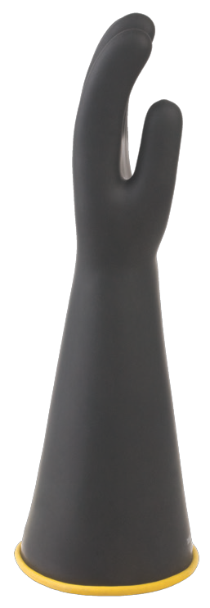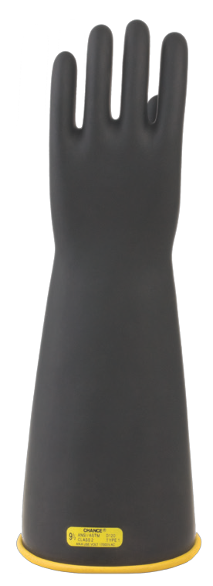& hands

•

•

•

Wide cuff
for improved comfort &
air-flow

Electrical puncture

ASTM label assures every glove has been made & tested to
ASTM D120
“Blooms” or “swells” from chemicals, oils
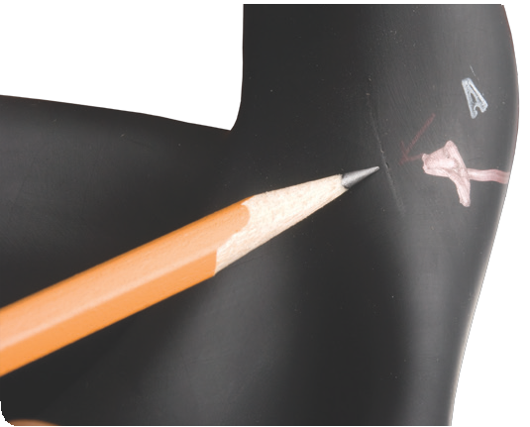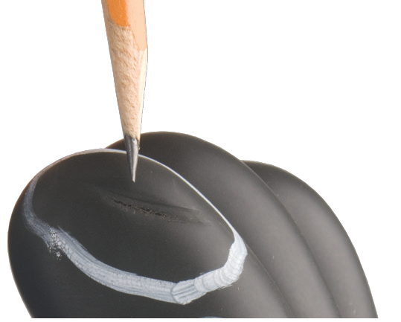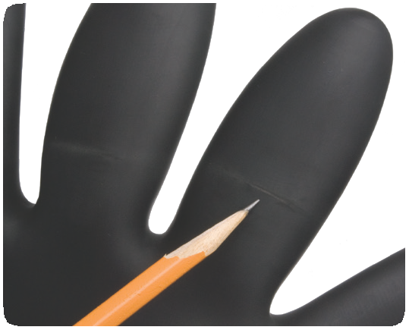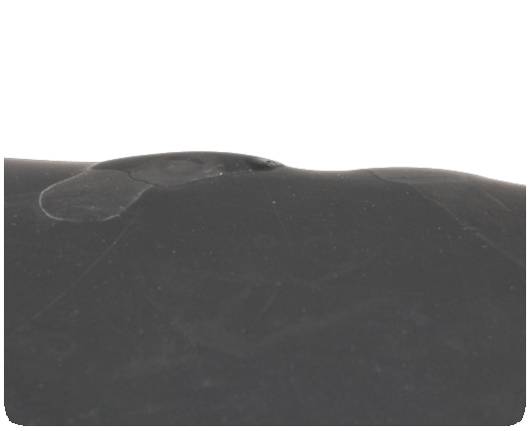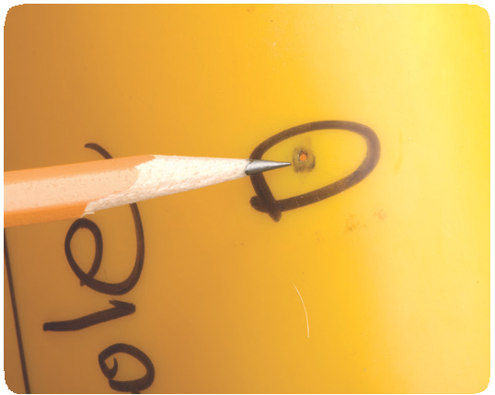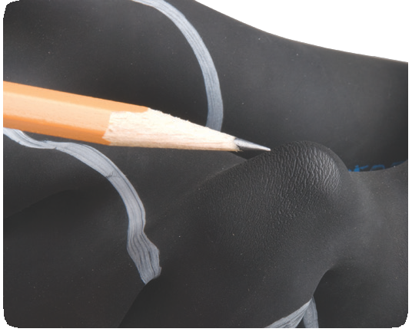
Rubber Insulating Gloves & Sleeves – 2650

Phone: 573-682-5521 Email: hpsliterature@hubbell.com Web: hubbellpowersystems.com
Page 2654 August 2015

Perform daily and periodic tests

Manual Inflation:
per ASTM F 1236

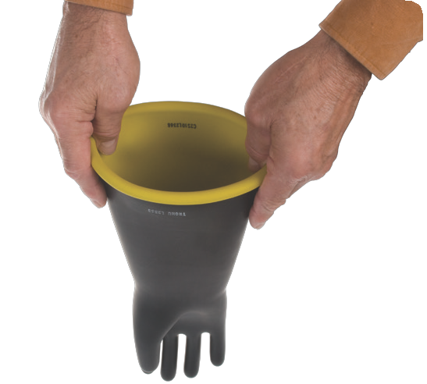1 Grasp glove

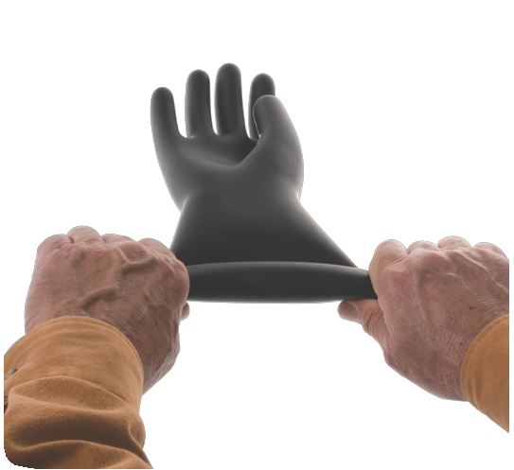2 Stretch to seal closed

See industry reference: ASTM F1236
Standard Guide for Visual Inspection
of Electrical Protective Rubber Products

Mechanical Inflators
ASTM F 1236 maximum inflation limits:
• Type I 2 times normal size
• Type II 11⁄4 times normal size

Test gloves both
Outside
and Inside Out

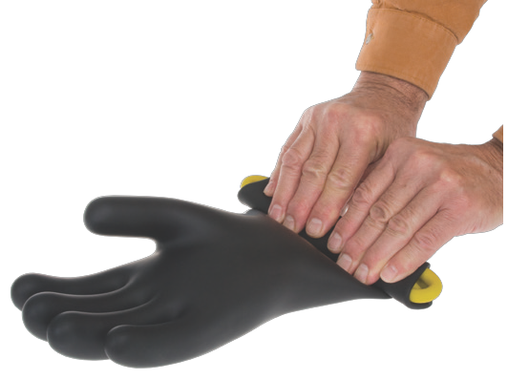3 Press and roll tightly

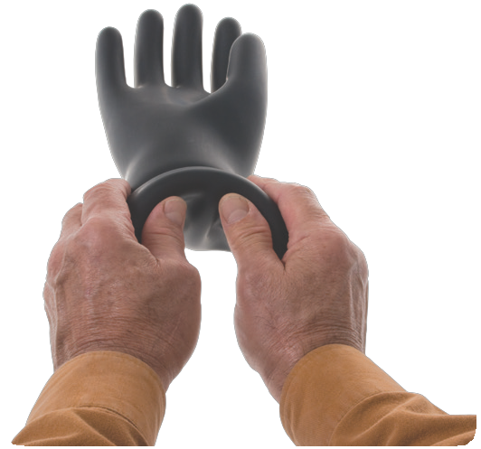4 Twirl glove, rotating on rolled ends
6 Hold close to ear, squeeze to add pressure, listen and feel for pinhole leaks

7 Turn glove inside out and repeat process
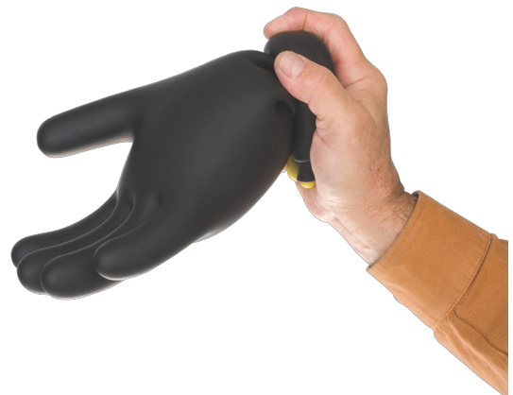

5 Entrap air by holding in one hand

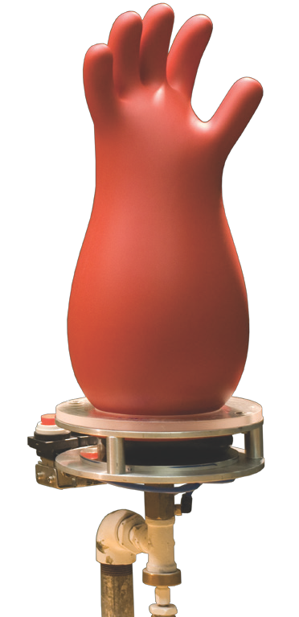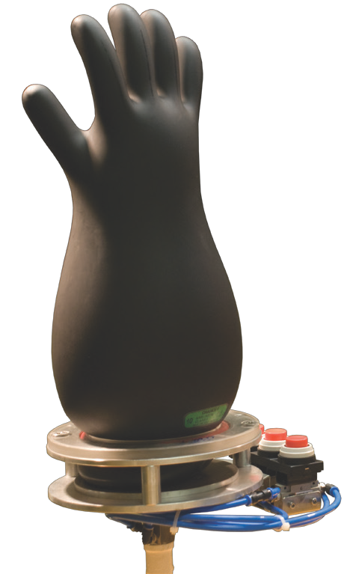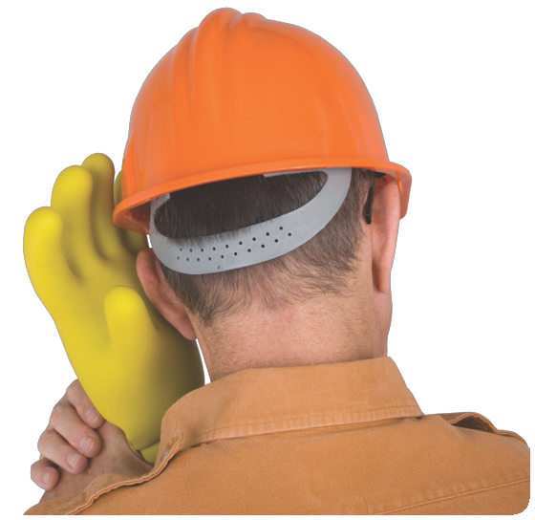Email: hpsliterature@hubbell.com Web: hubbellpowersystems.com
Rubber Insulating Gloves & Sleeves – 2650

August 2015

Page 2655

