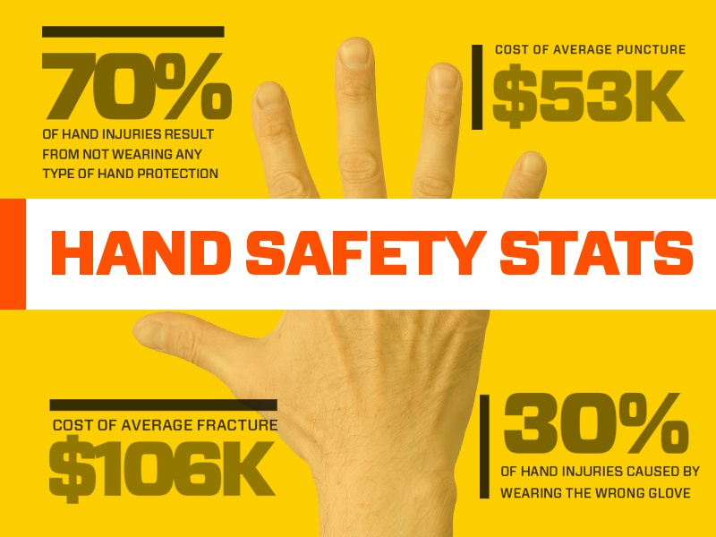
In 2015, there were 143,000 reported workplace hand injuries. The fact is that employers are providing hand protection for their employees. However, a quick look at OSHA’s hand injury stats reveals that workers were not wearing hand protection when injured. Actually over 70% of hand injuries in the United States occur to people are not wearing gloves.
Another interesting fact is that although overall injuries go down on the weekends, laceration injuries account for a higher proportion of weekend injuries. We can speculate that workers are less likely to wear safety gloves on the weekend, but this is really just speculation.
Hand injury statistics reveal how costly and painful on-the-job injuries can be. These injuries do not just hurt workers; companies suffer costs due to injuries, compounded by the loss of productivity. The question becomes “What is the true cost of an injury?” Whether you are searching for safety information to present to your company, or if you are looking to learn more about hand injury statistics, check out the surprising safety impacts that reveal the true cost of an injury. Clearly, the associated costs are tied to injury type. Next, let us break down incidents by injury type using data from The Bureau Of Labor Statistics.
- There were 186,830 nonfatal occupational injuries to hands and wrists that involved days away from work
- Wrist injuries led to 15 median days away from work and hand injuries led to 5 median days away from work
Number of injuries to hands and wrists by nature of injury are broken down as follows:
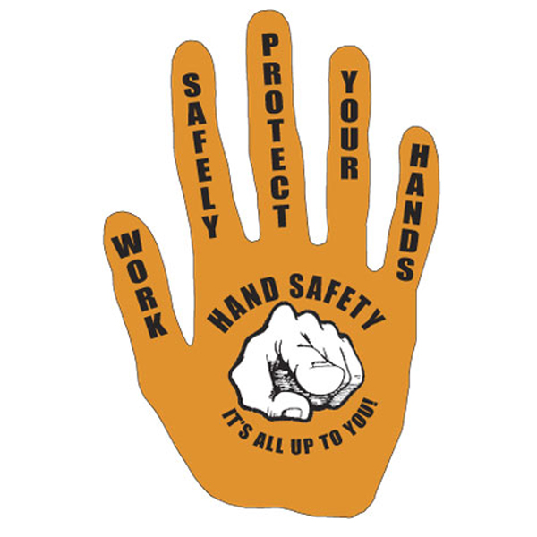
- 30,400 sprains, strains, and tears
- 17,000 fractures
- 12,300 pain and soreness
- 6,790 bruises and contusions

